Preparing the Development Environment
Jeremiah (Jay) Case
SNHU
CS-330
Professor Lles
7/1/2026

Preparing the Development Environment
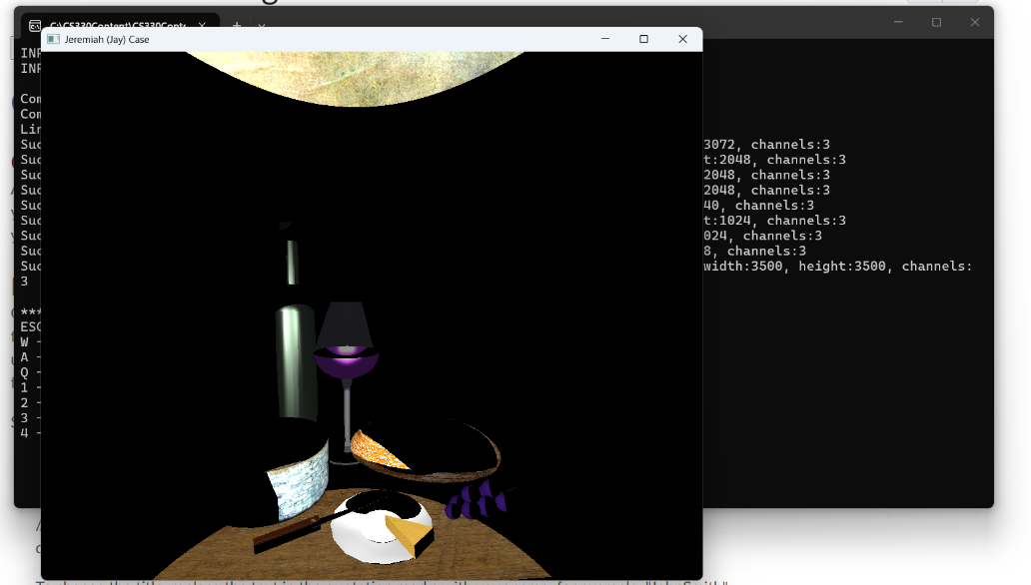
Setting up the OpenGL development environment presented a few challenges, but I was able to resolve them through troubleshooting. When I first attempted to build the OpenGLSample project, Visual Studio displayed an error stating that the Visual Studio 2022 v143 C++ build tools could not be found. Since the project depended on those tools, it would not compile successfully. I resolved the issue by opening the Visual Studio Installer, confirming that the Desktop Development with C++ workload was installed, and ensuring the required C++ build tools and Windows SDK were available. After updating the installation, I rebuilt the project and confirmed that the build completed successfully.

Once the build issue was resolved, I modified the window title in the MainCode.cpp file to display my name instead of the default “OpenGLSample.” I then ran the application and verified that the title bar displayed my name and that the 3D scene containing the wine glass, bread, and cheese rendered correctly. Completing this setup helped me become familiar with the Visual Studio development environment and confirmed that my OpenGL development environment is fully configured for future assignments.

